# Microservices: A Comprehensive Guide for Architects and Developers

This document provides a detailed overview of microservices architecture, exploring its core principles, benefits, challenges, and best practices. It's designed for software architects and developers seeking to understand and implement this powerful paradigm for building scalable and resilient applications.

# Understanding Microservices Architecture

###### Microservices architecture is an approach to developing a single application as a suite of small services, each running in its own process and communicating with lightweight mechanisms, often an HTTP resource API. These services are built around business capabilities and are independently deployable by fully automated deployment machinery.

Unlike traditional monolithic applications, where all components are tightly coupled, microservices promote loose coupling, allowing for greater agility, scalability, and resilience. Each service is responsible for a specific business function and can be developed, deployed, and scaled independently of the others.

Decoupled

Services are independent.

Business-Centric

Organized around capabilities.

Autonomous

Independently deployable.

Key Principles of Microservices

Several core principles underpin a successful microservices implementation, guiding design decisions and operational strategies. Adhering to these principles helps unlock the full potential of the architecture.

1

Single Responsibility

Each service focuses on one specific business capability.

Independent Deployment

2

Services can be deployed without impacting others.

Decentralized Data Management

3

Each service owns its data store.

Loose Coupling

4

Services interact via well-defined APIs.

Failure Isolation

5

Failure in one service doesn't bring down the whole system.

## Benefits of Microservices

Adopting a microservices architecture offers numerous advantages that directly impact development velocity, operational

efficiency, and system resilience.

#### Improved Scalability

Individual services can be scaled independently based on demand, optimizing resource utilization and cost. This is crucial for applications with fluctuating loads or components requiring different scaling factors.

#### Enhanced Agility and Productivity

Small, independent teams can develop, test, and deploy services faster, leading to quicker feature delivery and higher team productivity. The reduced scope per service simplifies development cycles.

#### Increased Resilience

Failure in one service is isolated, preventing cascade failures across the entire application. This leads to more robust and fault-tolerant systems. Circuit breakers and bulkheads are common patterns used here.

#### Technology Diversity

Teams can choose the best technology stack (language, framework, database) for each service, leveraging specialized tools for specific tasks. This flexibility allows for optimal performance and development experience.

Challenges of Microservices

While microservices offer significant benefits, they also introduce complexities that require careful consideration and planning. Addressing these challenges is crucial for a successful implementation.

### Distributed Complexity

Managing numerous independent services, inter- service communication, and data consistency across distributed systems can be complex.

### Operational Overhead

Increased need for robust monitoring, logging, deployment automation, and orchestration tools due to the distributed nature.

### Debugging and Testing

Troubleshooting issues across multiple services can be challenging, requiring sophisticated tracing and observability tools.

### Cost Management

Running multiple services may incur higher infrastructure costs compared to a monolithic application if not optimized correctly.

Service Communication Patterns

Effective communication between microservices is fundamental. Various patterns exist, each with its own trade-offs regarding

latency, reliability, and complexity.

|  |  |  |
| --- | --- | --- |
| **Synchronous (REST/gRPC)** | Services make direct requests and wait for responses, typically via HTTP or RPC. | Real-time data retrieval, request/response workflows, immediate feedback to user. |
| **Asynchronous (Message**  **Queues/Event Bus)** | Services communicate via messages, without waiting for an immediate response. | Long-running processes, event-driven architectures, decoupling services for scalability. |
| **API Gateway** | A single entry point for all client requests, routing them to the appropriate services. | Authentication, load balancing, request  aggregation, rate limiting. |

Choosing the right communication pattern depends on the specific requirements of the interaction, including response time, reliability needs, and the level of coupling desired.

Data Management in Microservices

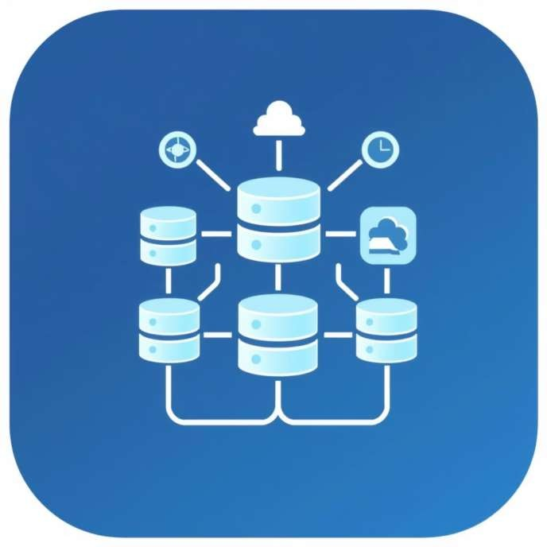

One of the most significant shifts in microservices is the approach to data. Each service typically owns its data, promoting decentralization and autonomy.

Database Per Service

Each microservice manages its own private database, ensuring strong encapsulation and preventing direct access from other services. This choice allows services to use the most suitable database technology for their specific needs, e.g., a relational database for transactional data, a NoSQL database for flexible schemas, or a graph database for complex relationships.

This approach enhances autonomy, as schema changes in one service's database do not

impact others, and it improves fault isolation.

Deployment and Orchestration

Automated deployment and robust orchestration are critical for managing the lifecycle of numerous microservices efficiently.

###### Containerization (Docker)

Packaging services into containers ensures consistency across different environments and simplifies deployment.

###### Orchestration (Kubernetes)

Tools like Kubernetes automate the deployment, scaling, and management of containerized applications.

###### CI/CD Pipelines

Automated continuous integration and delivery pipelines enable rapid and reliable releases of individual services.

###### Service Mesh (Istio, Linkerd)

A dedicated infrastructure layer for handling service-to-service communication, reliability, and security.

Observability in Microservices

Given the distributed nature of microservices, gaining visibility into their behavior and performance is paramount for effective

troubleshooting and maintenance.

##### Monitoring

95%

##### Logging

88%

Collecting metrics (CPU usage, memory, request rates, error rates) from each service to track health and performance.

Aggregating logs from all services into a centralized system for easy searching and analysis.

##### Distributed Tracing

75%

##### Alerting

60%

Tracking requests as they flow through multiple services to understand latency and identify bottlenecks.

Setting up notifications for abnormal behavior or performance degradation in services.

Implementing robust observability practices ensures that development and operations teams can quickly detect, diagnose, and resolve issues in a complex microservices environment.

## Best Practices and Future Trends

To maximize the benefits of microservices and mitigate their challenges, adopting established best practices and staying

abreast of future trends is essential.

* **Domain-Driven Design (DDD):** Align services with well- defined business domains.
* **Bounded Contexts:** Clearly define service boundaries to minimize dependencies.
* **Loose Coupling, High Cohesion:** Services should be independent but internally focused.
* **Automate Everything:** CI/CD, testing, deployment, and monitoring.
* **Embrace DevOps Culture:** Foster collaboration between development and operations.
* **API First Design:** Define clear APIs for service interactions.

"The biggest trend will be about how to cope with the complexity of many services, and to build better tools to manage that complexity." - Martin Fowler

Future trends include further adoption of serverless computing for microservices, enhanced AI/ML-driven observability, and the evolution of service mesh technologies to simplify inter-service communication and security in highly distributed environments.